**Topics in Software Engineering**

**Assignment 1**

**Group members:**

**Ahsan Abdullah (FA19-BSE-007)**

**Malik Muhammad Huzafah Khan (FA19-BSE-043)**

**Usama Tariq (FA19-BSE-063)**

**Hasnan Mehmood (FA19-BSE-023)**

**Topics in Software Engineering I**

**CSE 350**

Submission Oct 3, 2022 till 10AM.

**Assignment 1 Marks 10**

Enable the project using any IDE for code review. It would be better to use Eclipse or Netbeans. You may use VS Code too.

1. Explore your project and find all options discussed in lecture 2 from Chapter 2. You need to prepare a google doc that highlights the potential issue that your code has. You may identify these issues with the help of

i) Identify deprecated technology or APIs. Just report the diagram.

ii) Potential issues missing in the documentation but available in the code

iii) missing of technical documentation ( if applicable )

**Sol:**

Documentation is not available for current code.

1. Use PMD to help identify potential coding errors and customize the rules you use to make sure only pertinent rules are applied to your source code.
   1. Create & view code issues directly from your editor
   2. Track & prioritize code improvements like technical debt
   3. Check your code quality
   4. Apply at least 3 PMD rules with the help of tool
   5. Generate the Abstract Syntax Tree of your source code suing PMD.
2. System.out.println is used in the project code while according to PMD System.out.print is more appreciable to be used.

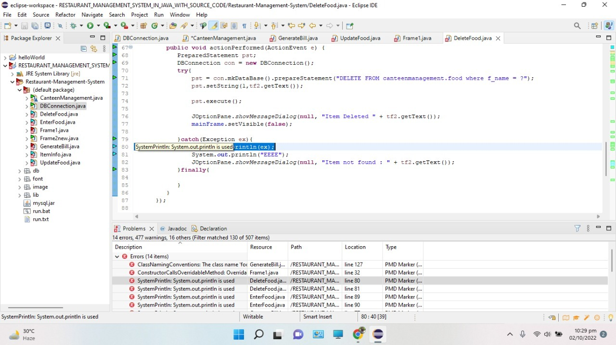

1. There is a conventional error for class name foodCart as class names are written in CamelCase i-e FoodCart

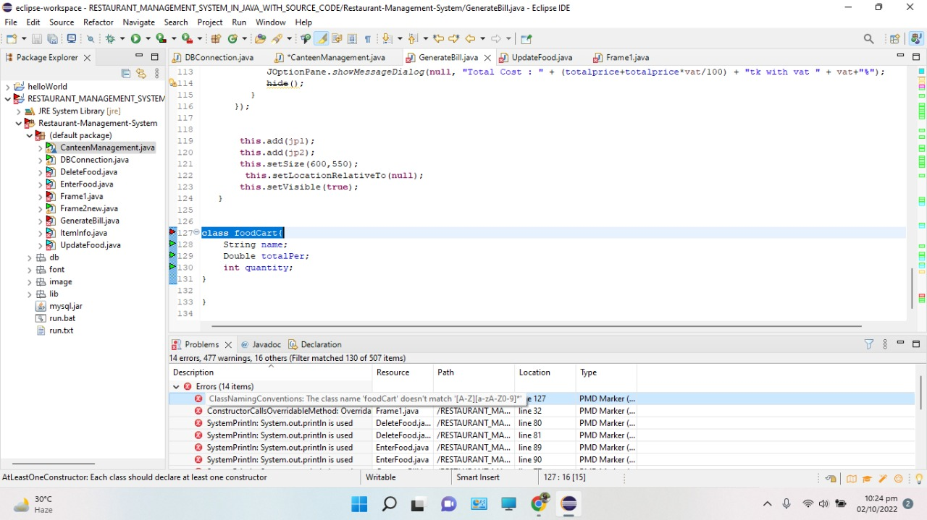

1. ConstructorCallsOverridableMethod: Overridable method "init' called during object construction, overrideable methods should not be called according to PMD

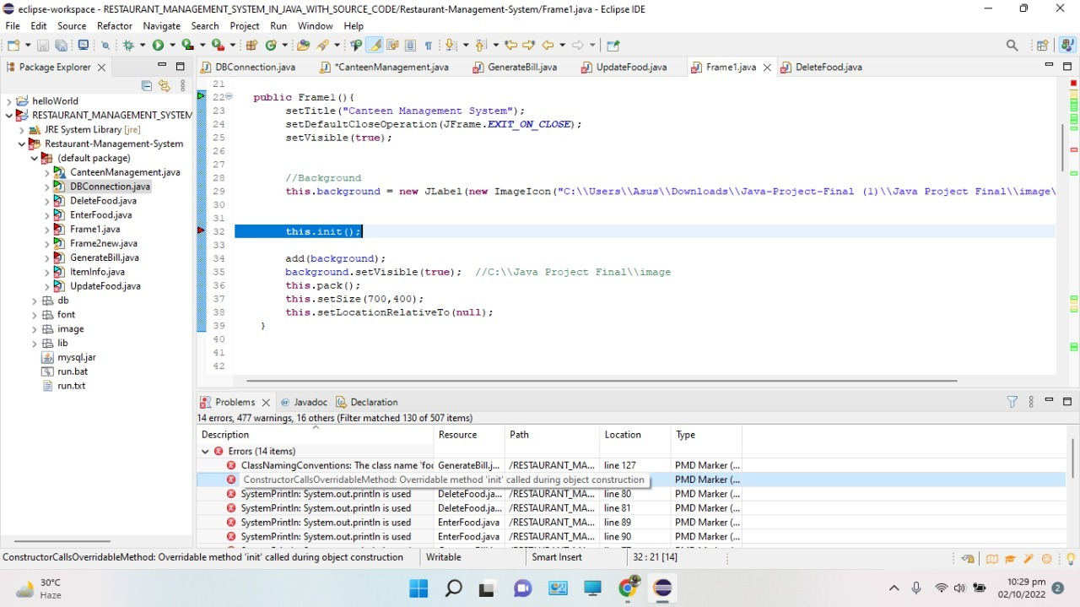

1. Use the Check Style tool to review your code. At least apply 2 rules on your code using CheckStyle

**Solution:**

CheckStyle review Problems

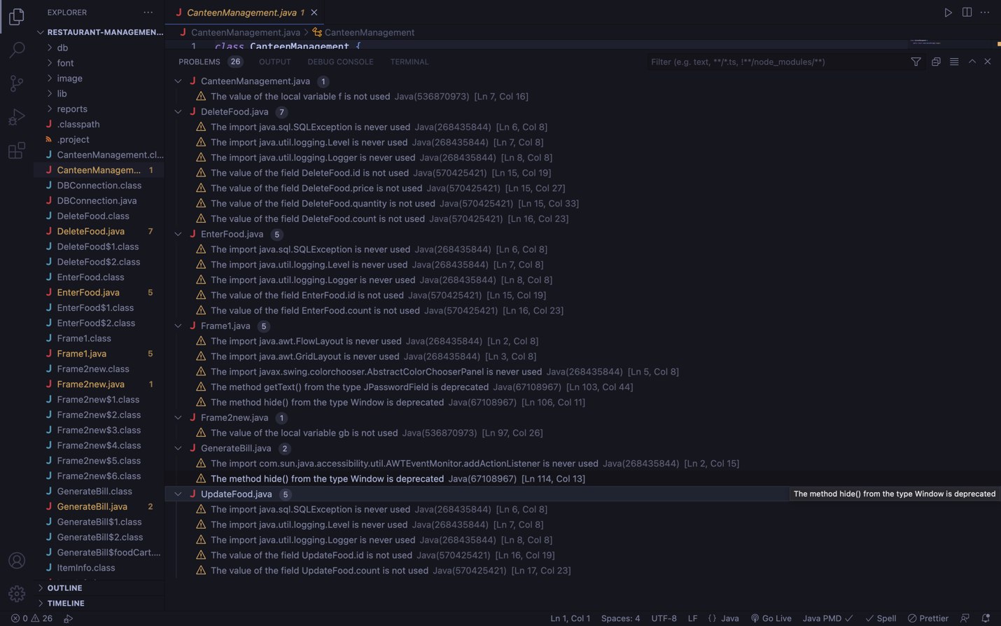

1. getText() is deprecated so checklist suggestion was to add @suppressWarnings

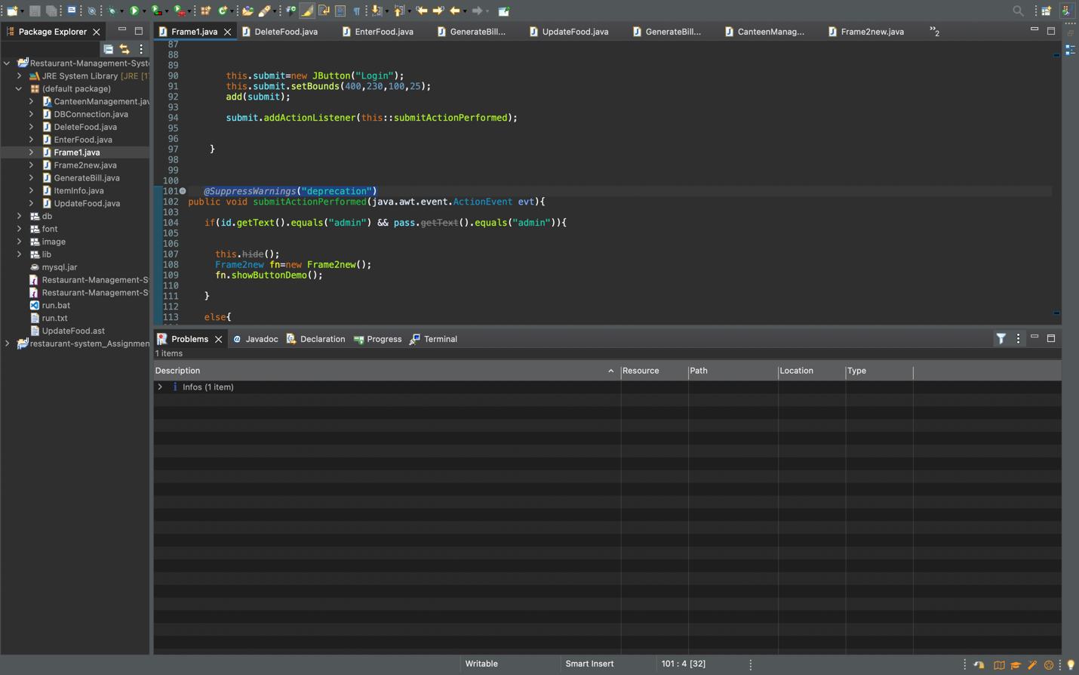

1. The serializable class Frame1 does not declare a static final serialVersionUID

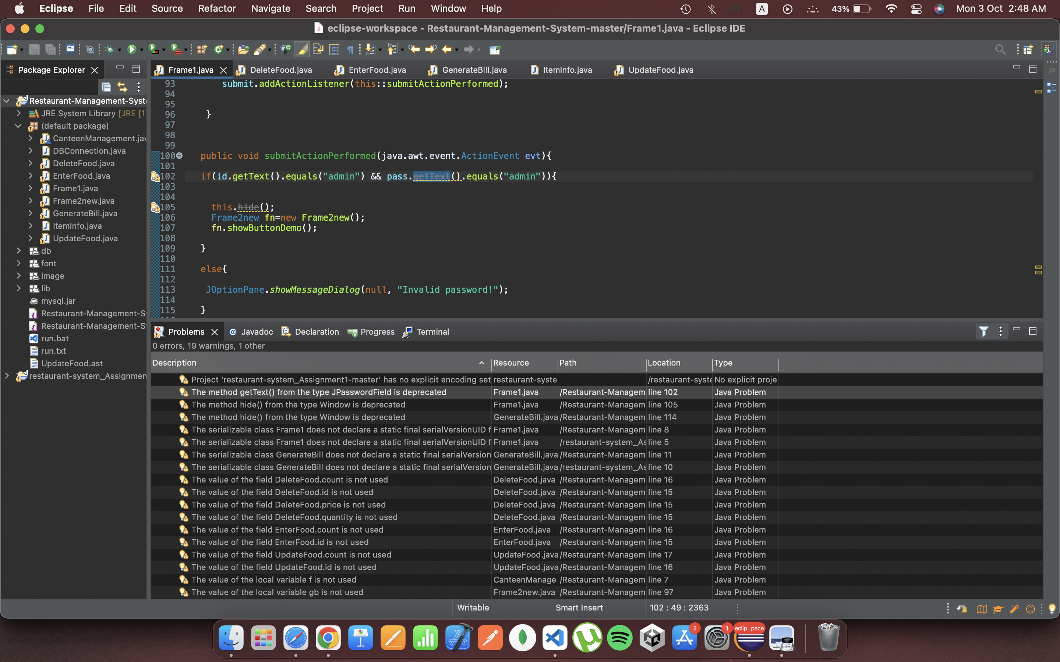

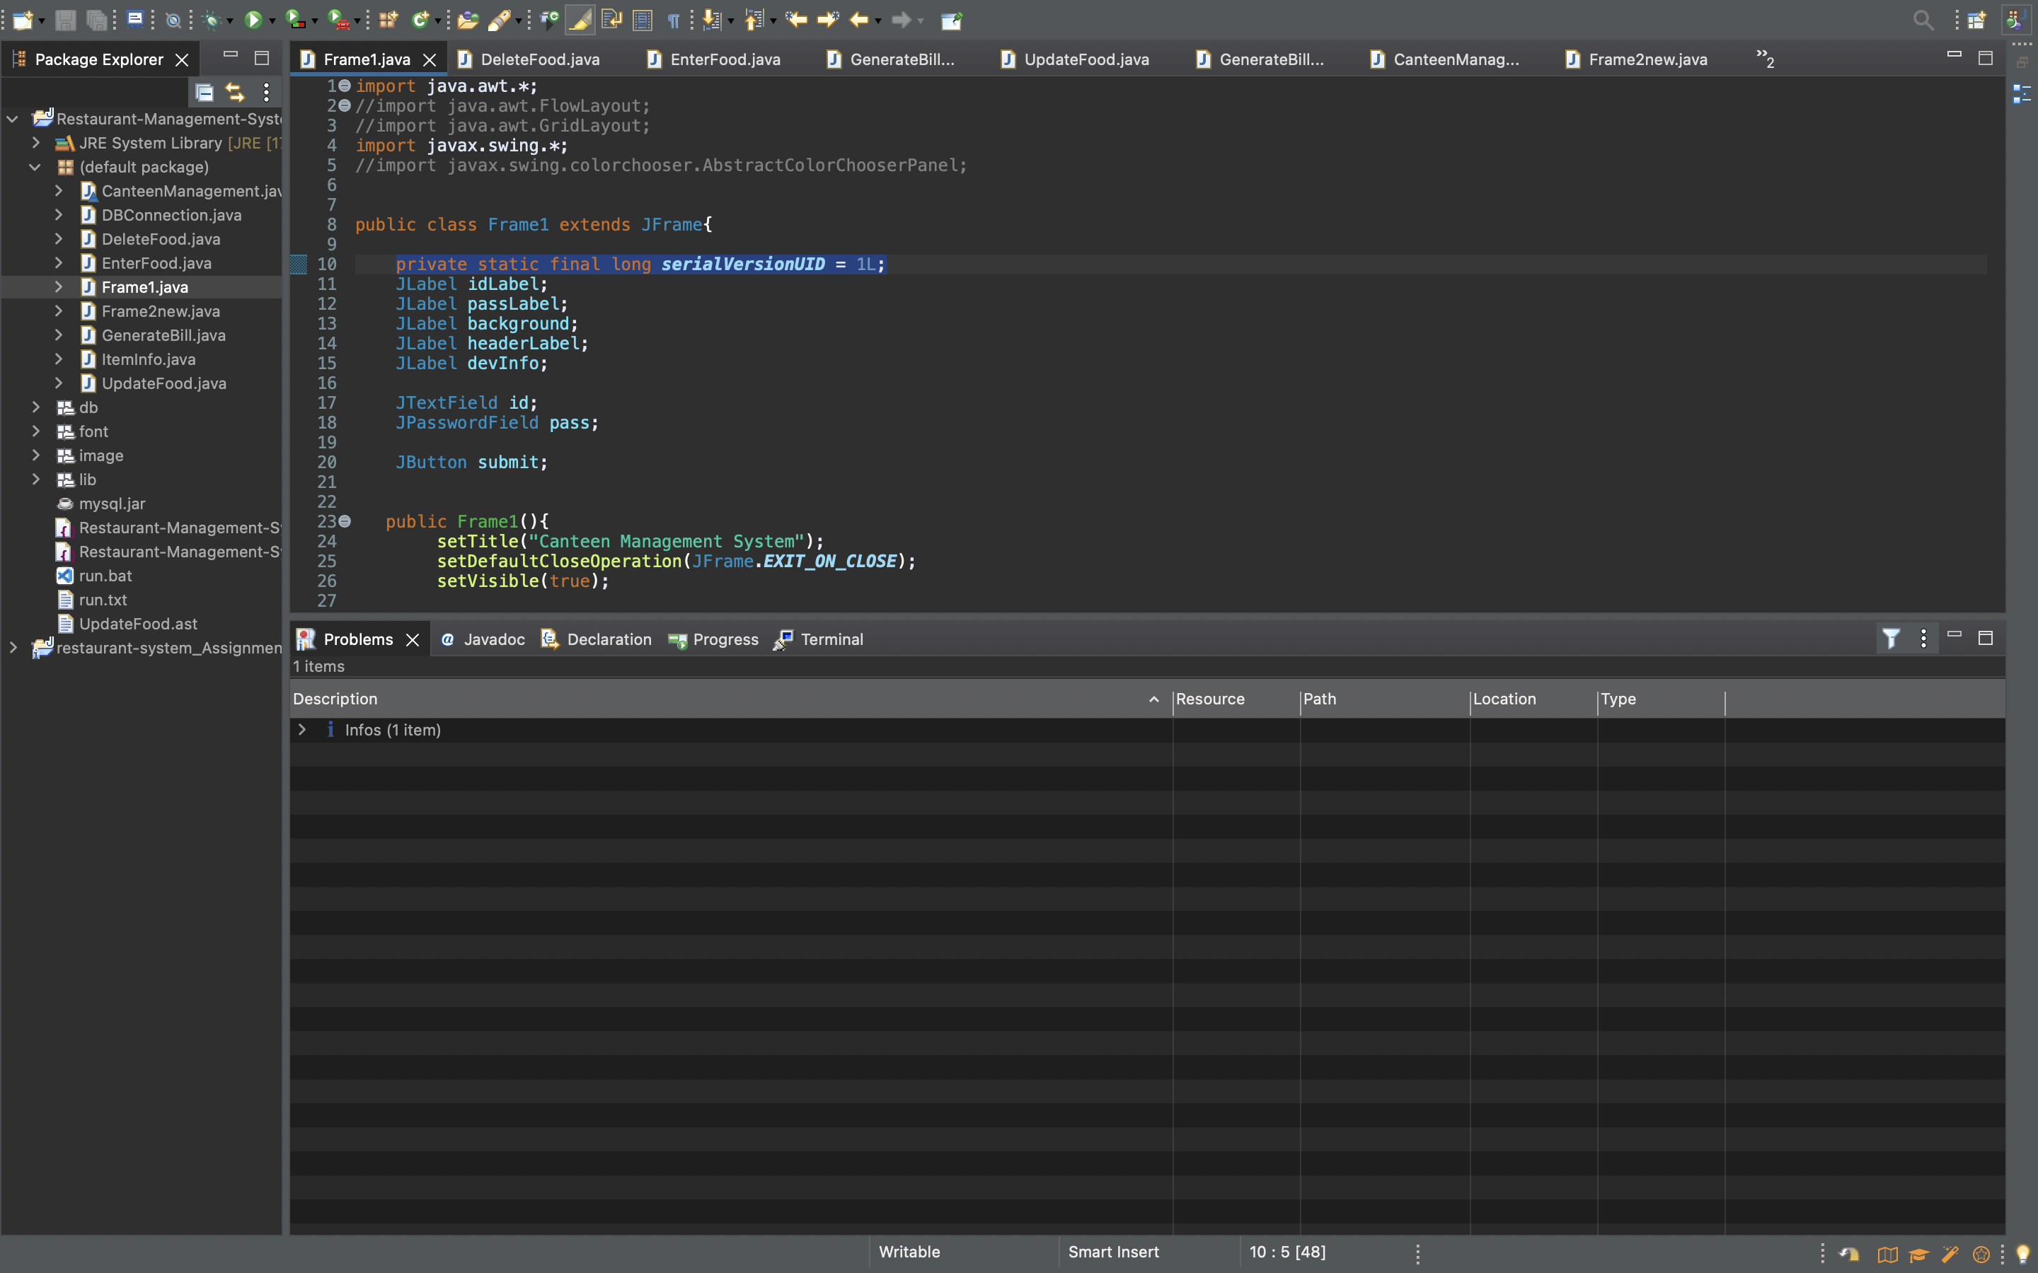

1. After removing all warnings



Code was finally running error free

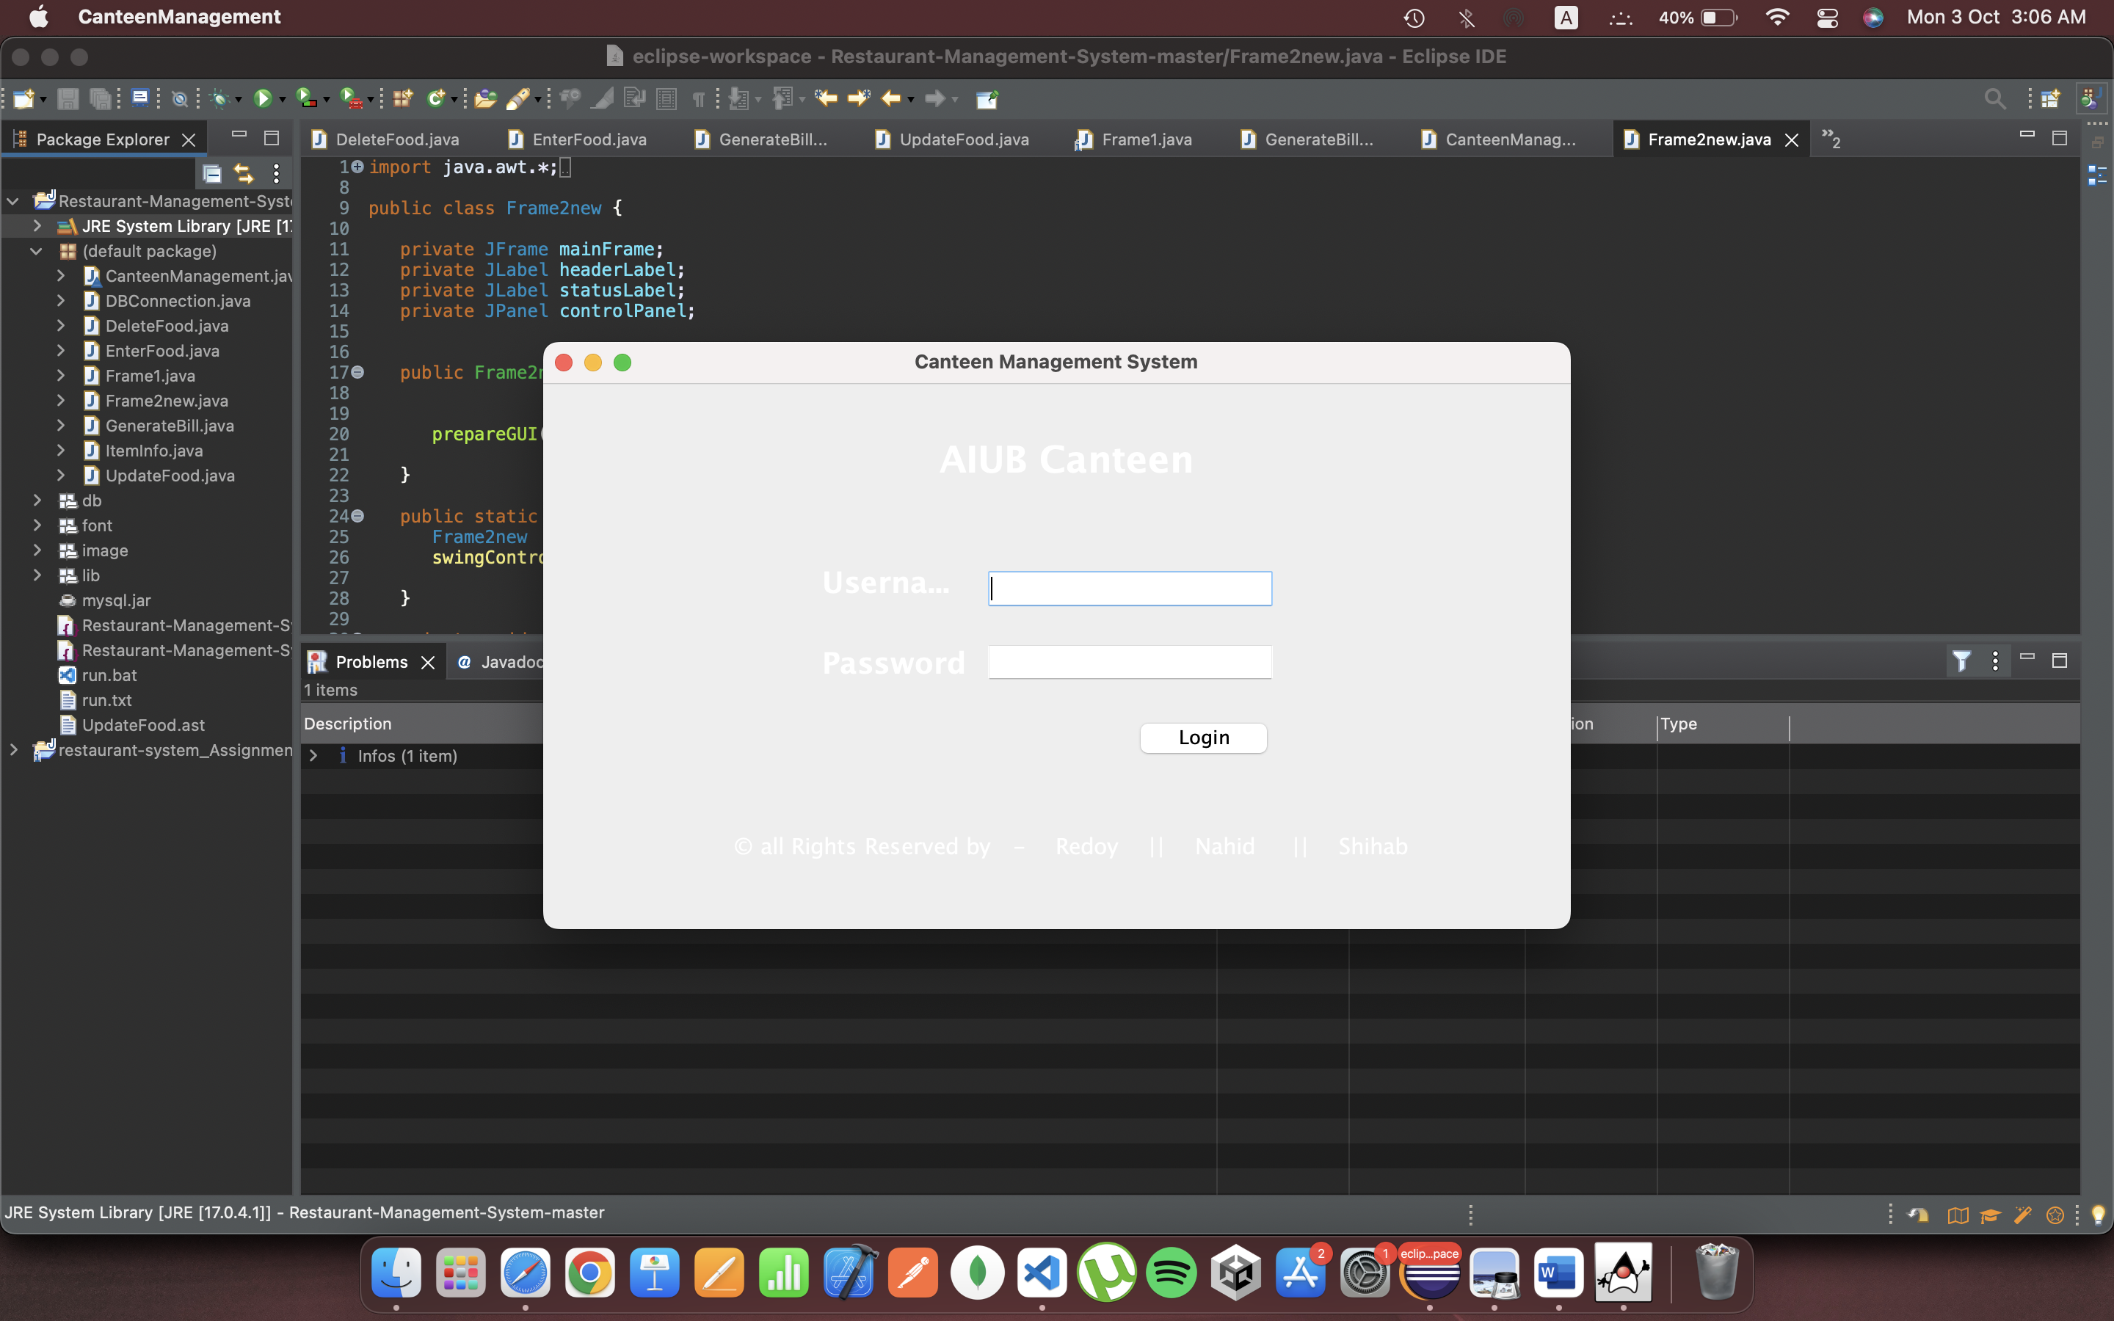

Abstract Syntax Tree is available in GitHub code repo.

GitHub Link

https://github.com/ahsanabdullaa/fa19-bse-007-043-063-023/tree/main/Restaurant-Management-System